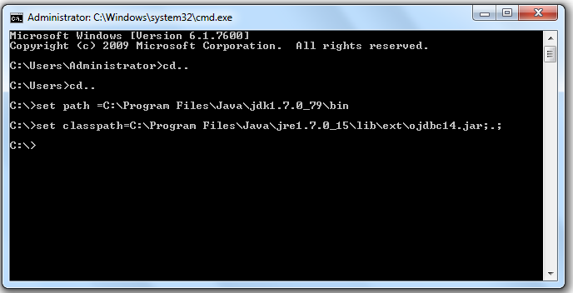

<https://www.javatpoint.com/example-to-connect-to-the-oracle-database>

[download the jar file ojdbc14.jar](https://www.javatpoint.com/src/jdbc/ojdbc14.jar)

1. paste the ojdbc14.jar file in jre/lib/ext folder
2. create table student in oracle as

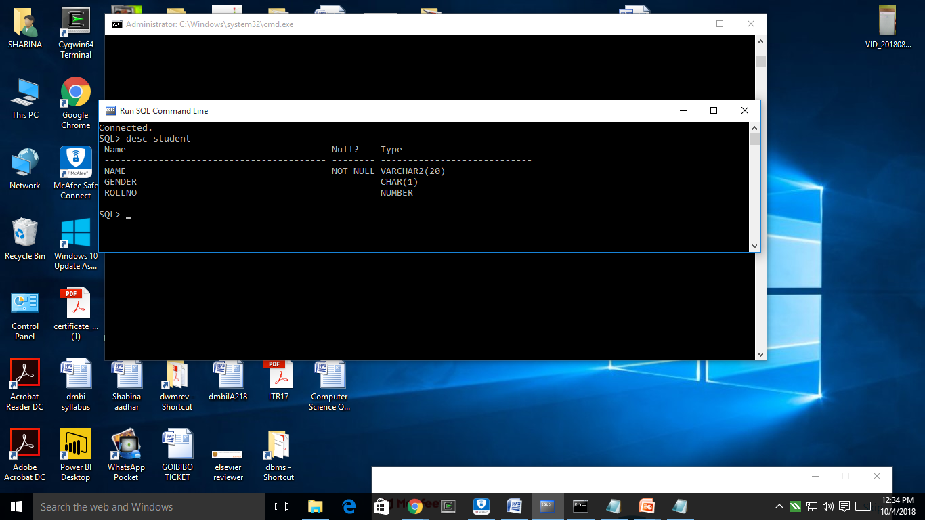

1. save the below program with main class name into C:\

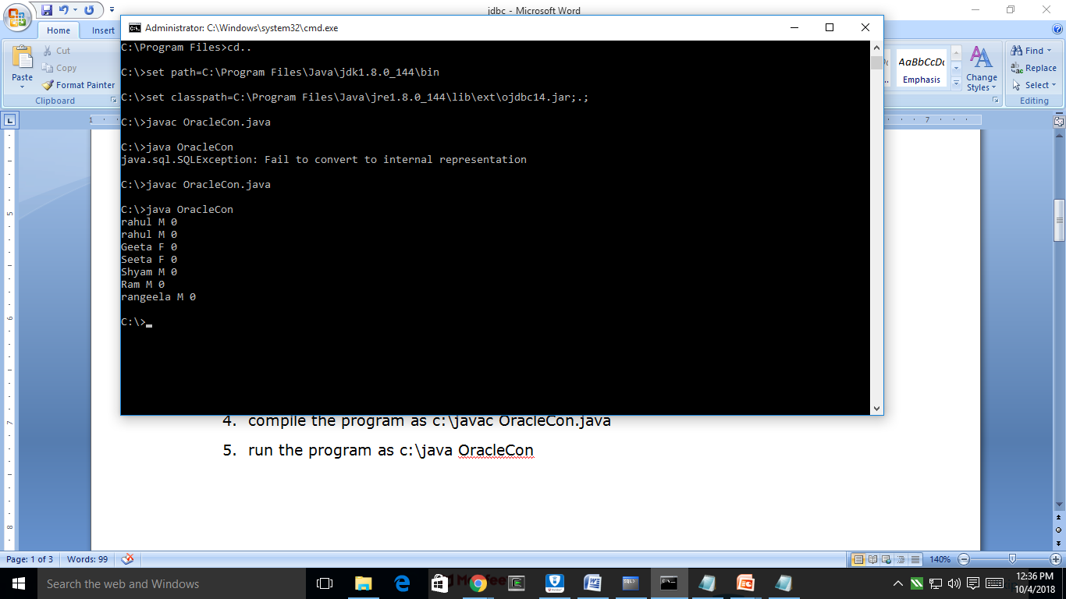

1. compile the program as c:\javac OracleCon.java
2. run the program as c:\java OracleCon

//program for jdbc connection

import java.sql.*;

class OracleCon{

public static void main(String args[]){

try{

//step1 load the driver class

Class.forName("oracle.jdbc.driver.OracleDriver");

//step2 create the connection object

Connection con=DriverManager.getConnection(

"jdbc:oracle:thin:@localhost:1521:xe","system","manager");

//step3 create the statement object

Statement stmt=con.createStatement();

//step4 execute query

ResultSet rs=stmt.executeQuery("select * from student");

while(rs.next())

System.out.println(rs.getString(1)+" "+rs.getInt(2));

//step5 close the connection object

con.close();

}catch(Exception e){ System.out.println(e);}

}

}